Drawing – Azalea Middle School  Ms. Zocchi  (pronounced Zah-Key) | Email: carolz@brookings.k12.ca.us (questions/concerns)  Website: www.zocchi.weebly.com (daily assignments posted)  Grades: powerschool.com (grades, summative assessments)

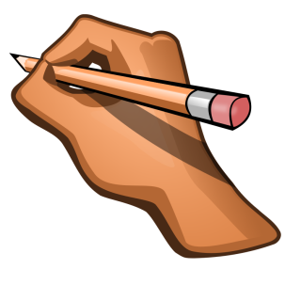
This is a beginning art class, focused on the basic concepts of drawing. We will work on lines, shapes, shading, perspective and composition elements. While this is an elective, they will receive a grade for the following:

- Complete assignments weekly (like draw a flower – not based on skill but elements)
- Quizzes quarterly on terms (like perspective and the rule of 3s)
- Drawing in class – on task performance (students should be drawing most of the period)

SUPPLIES – Students bring DAILY:
If students do not bring supplies, basic #2 pencils and copy paper will be provided.
- Sketchbook (found at Fred Meyer or sometimes Dollar Tree)
- Pencils (various inexpensive kits available with several weights of pencils – 2B, 6B are common)
- Sharpener with container (to catch shavings)
- Pencil pouch (contain supplies and avoid using art supplies for class work or home work)
- Eraser (gum type or graphite specific)
- Optional – shading sticks (rolled pieces of paper)

Note: It is recommended that supplies are checked monthly so students are equipped daily.

ELECTRONIC DEVICES – We will use technology every day:

I welcome use of personal devices (cell phones, ipods, ipads, Kindle’s, e-readers). I will temporarily confiscate any device used for non-academic use in the following time-frame:
1st in class offense – student must pick up from my desk at the end of the period
2nd in class offense – student must pick up from my desk at the end of the DAY
3rd in class offense – parent must pick up from office during office hours

Note: We will often look up objects to draw and watch videos on YouTube for instructional practices.
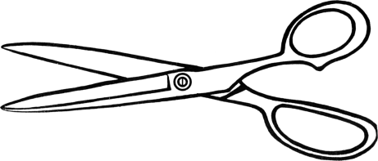
------------------------------------------------------------------------ ----------------------------------------
Please sign and return by Friday, Sept 9th.
I have read Zocchi’s syllabus and will abide by the student and parent conduct code according to Azalea Middle School Handbook and this syllabus.

Print Student’s Name________________________ Period_________________

Student’s Signature__________________________ Parent’s Signature__________________________

