Winter Book Project
- Final Draft of blurb – Due Wed, Nov 15 (Jupiter/Turn it in)
- Rough Draft of project – Due Friday, Nov 17 (Paper Script/Outline)
- Final Draft of project – Due Mon, Nov 28 (Posted to YouTube
Pick one of the three options:
1. Book Talk (speech): Deliver a Standard 90 second memorized speech. You may not read it from a paper or any notes. Do not reveal any major spoilers nor the ending. Recommend practicing three times a day for three days prior to delivery. This speech will be recorded for a Bruin Buzz production and shared with the school.
2. Book Trailer (video): create a 90 second video with written text or an audio overlay, or a mixture of both to create a video uploaded to YouTube. You can use pictures in a slideshow, live action video, or stop motion animation. Video makers recommended: iMovie, Animoto, Wevideo. This video will be shared with the school.
3. Book Jacket or Movie Poster (draw/paint): create an original artistic piece of work, either a book cover depicting key symbols or characters that would entice readers to read this book. A two sentence blurb should be included on the poster for a movie; a 4 to 7 sentence blurb should be included on a book jacket. Recommended size 8 x 10 or larger on quality art paper or mounted canvas. This art piece will be posted in the library.
*Students who are not prepared on Monday will automatically default to the Book Talk speech and will be required to deliver their blurb on Tuesday, Nov 29th.
Grading Elements:
- Blurb – creates suspense; uses proper grammar; avoids spoilers; avoids plagiarism
- Presentation – polished end product that demonstrates quality preparation time outside of class
- Tone/mood – message to audience is clear and consistent to the theme and genre of the book

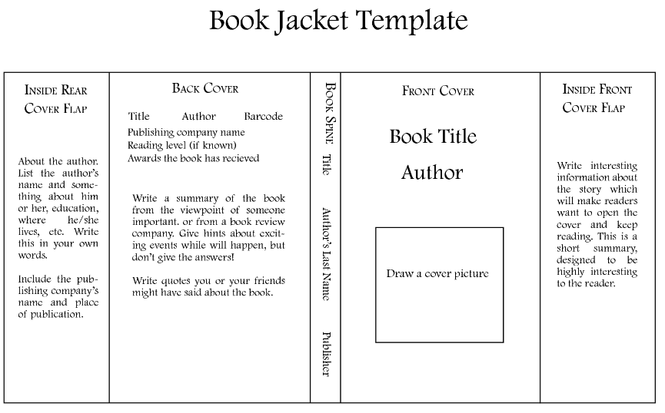
Video Storyboard Template
