Student Name________________________ Per_______
Why Do the Boy Scouts Want to Include Girls?
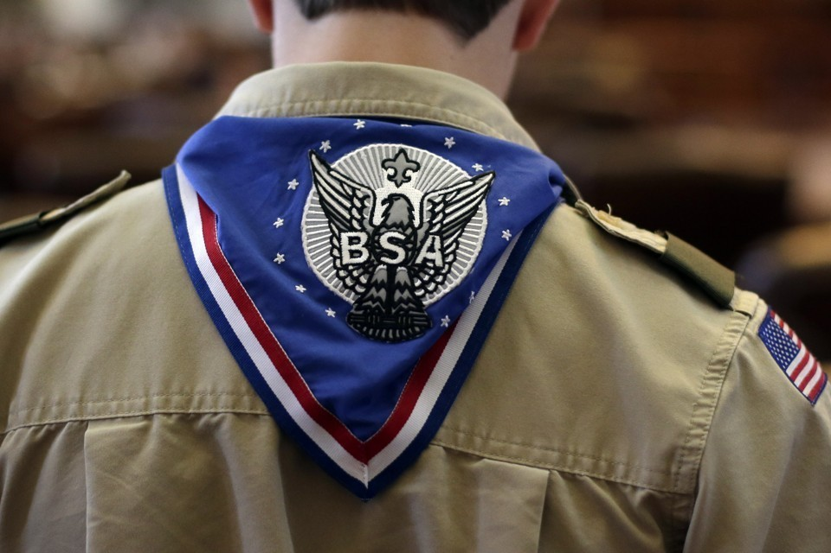
The organization’s decision overturns a historic and defining separation, raising questions about their timing and how they differ from the Girl Scouts of the USA
TAYLOR HOSKING by The Atlantic
OCT 12, 2017

On Wednesday, the Boy Scouts of America announced it will soon allow girls to join the organization as Cub Scouts and earn the rank of Eagle Scout, marking a significant policy shift in the organization’s over 100-year history. Why Do the Boy Scouts Want to Include Girls?

“The values of Scouting—trustworthy, loyal, helpful, kind, brave and reverent, for example—are important for both young men and women,” said Chief Scout Executive Michael Surbaugh in a statement. “We strive to bring what our organization does best—developing character and leadership for young people—to as many families and youth as possible as we help shape the next generation of leaders.”
It’s the latest move by the organization to attempt to open up its membership. In 2013, the organization lifted the ban on openly gay scouts and in 2015, ended the prohibition on gay leaders. Earlier this year, the Boy Scouts of America also said it will allow scout members that self-identify as male, creating room for transgender members.
Wednesday’s announcement, however, received pushback from the Girl Scouts of the USA, which has long been an alternative for girls and recently criticized the Boy Scouts for considering opening its doors to girls. “The need for female leadership has never been clearer or more urgent than it is today—and only Girl Scouts has the expertise to give girls and young women the tools they need for success,” the Girl Scouts said in a statement.
The two organizations have developed markedly different curriculums over the past century. In their earliest years, Boy Scouts teachings were imbued with a more frontiersmen ethos connected to the national narrative of moving west, while the Girl Scouts were a more urban movement teaching both domestic and outdoor skills, said Tammy Proctor, the head of the history department at Utah State University and author of the book Scouting for Girls: A Century of Girl Guides and Girl Scouts.
I spoke with Proctor in order to understand the historic separation between the two organizations and why they seem to be at odds over the question of co-education. Our conversation has been lightly edited for length and clarity.
Interview:
Tammy Proctor: When [Robert Baden-Powell's guide book for scouting] Scouting for Boys was first published serially in 1907, there was a lot of interest among both boys and girls. It was a movement designed for boys, but a lot of girls got a hold of the book and were doing scouting. In some cases, they even wrote-in to headquarters using their initials rather than their first names, so they were kind of unofficial girl scouts. But early leadership got concerned because they were afraid that boys would be turned off from a youth movement that had girls in it. They thought it would be unappealing; it wouldn’t be manly.
Baden-Powell enlisted his sister as head of the girls version of the movement, called the Girl Guides, and published the first girls version in 1909 and then the organization got off the ground in 1910. These early years were kind of messy and they really felt strongly that it should be a single-sex movement for each, that their development was different. When the movement spread to other countries, including the U.S., it did so as a single-sex movement.
The British Boy Scouts developed boy scouting movements in other places and the Girl Guides developed girl scout movements in other places—and they weren’t always at the same time. There might be a year or two lag between a boys movement and a girls movement. In the U.S., the two movements were pretty different from the beginning. Juliette Low, who was the founder of the Girl Scouts, had actually worked in a Girl Guides troop in Britain. And in the same way, the Boy Scouts were founded out of the boy movement in Britain.
Hosking: How is the purpose of the Girl Scouts different than the Boy Scouts?
Proctor: From the beginnings of the two movements, there’s been friction. In the 1920s, the Boy Scouts actually sued the Girl Scouts in court over the name “scout.” They thought it was a male term. There were legal battles—and battles in the media —over this. In some countries, there’s a closer relationship between the Boy Scouts and Girl Scouts. But in the U.S., they’ve functioned as totally separate organizations and they don’t always get along.
That being the case, they developed separately. The Boy Scouts built different kinds of alliances and they’ve built an image of being a more conservative movement since the 1980s. They also have a very close relationship here in Utah to the Church of Latter-Day Saints, for instance. But the Girl Scouts have gone the other way: They’ve pushed the boundary a little bit since the 1970s and 1980s on women’s occupation; they’ve taken on different issues regarding sexual identity, and pushed to diversify at least in their language. The Girl Scouts headquarters are in New York City, which doesn’t define who your organization is, but it orients your organization differently than having headquarters in Texas, where the Boy Scouts are.
Hosking: Did the Girl Scouts face backlash for wanting to empower women as they expanded?
Proctor: The movement, from the beginning, has always had a pretty strong emphasis on empowering girls, but sometimes that meant empowering them to be strong mothers of families. It wasn’t to necessarily liberate girls from all of the roles they were expected to perform; it was to emphasize education and preparedness.
But in some communities over the years, the Girl Scouts have gotten fired for being too progressive with the social issues they take on and the projects they encourage. For example, they did a big career program in the 1960s and 1970s about girls in science, which involved girls going to a space center to learn about what it would be like to be an astronaut or taking girls to different kinds of occupations like firehouses. In some places, that pushed some buttons, but the national organization has stood pretty firmly behind that notion of empowerment, I think.
Hosking: If the two organizations have developed so independently, how did we get to a place where Boy Scouts feel pressured to allow girls in?
Proctor: There has been an ongoing debate about whether this should happen or not. Internationally, there are many countries that have co-educational scout movements. In Europe, in places like Scandinavia, they’ve merged Boy Scouts and Girl Scouts into one organization. But in those cases, the two organizations worked together and they merged to create a co-educational movement.
In the U.S. case, it looks like a turf war because the Girl Scouts are adamantly not participating. This is about the Boy Scouts allowing girls in. I think the Boy Scouts are under pressure because they’re losing members. They’re under pressure to do something new and look for new members in a broader way. It’s interesting that they’ve been emphasizing the Cub Scouts in their media because most people have fewer objections to co-education when kids are young than they do when they’re 15 or 16. And Boy Scouts have long-encouraged female leaders for the younger kids and have been less interested in having female leaders for teenage boys.
Hosking: Why are the Boy Scouts losing members?
Proctor: I think clubs generally in the U.S. have lost members. There’s literature that suggests kids are doing a lot more activities early, particularly sports, and they’re kind of overextended. To add on an additional activity of doing scouting might just be the tipping point. [Both Boy Scouts and Girl Scouts] have also had an issue recruiting leaders: Volunteerism in the U.S. has fallen precipitously in recent years.
The Boy Scouts have been struggling with a lot of issues regarding their social attitude, particularly regarding homosexuality. I’m not sure they’ve managed those well in the media. There was a fairly large alternative scout movement that was pushing back against policies that wouldn’t allow gay leaders and gay scouts. This close relationship they’ve had with the Church of Latter-Day Saints in recent years has contributed to their conservative image, too. The Mormon Church announced recently they might create their own movement, which would pull some members away, as well. But I think it may be overarching trends that started the decline, and they’ve been trying to respond to that in a variety of ways since maybe 30 years ago even.
Hosking: What would girls have to gain by joining the Boy Scouts?
Proctor: I think for girls joining a boys movement there’s a bit of a forbidden fruit factor that they can do anything boys can do, which doesn’t exist in the same way for boys wanting to join a girls movement. There’s a power dynamic there of girls being excluded in the past and now they can do anything a boy can do.
Kids don’t necessarily divide by sex segregation when they play or in their communities, so I think this allows groups of friends to join a movement together. Ironically, that’s what you were seeing in 1908 when these kids were getting a hold of the book before the boys movement was really founded. I had this great letter that a boy wrote in about how he and his sisters were starting a scout troop and it was because they were playmates and they were a group of friends. They weren’t really seeing it as ‘we’re boys and we’re girls,’ they wanted to just do this together.

