Lesson 1 Name________________Per________
Part A. Define the Example Words (use a dictionary or Google it)
Term/Definition | Example | Definition of Example
- therm/heat | thermograph
- gram, graph/written; drawn | telegraph
- hydro/water | hydrophobia
- top/place | topography
- mono/one | monologue
- multi/many | multicolor
- meter/measure | cyclometer
- pro/before; forward | program
- ic/of: pertaining to | graphic
- de/down: away | dehydrate

Part B. Practice breaking apart the examples and identifying the root definitions (use a dictionary or Google it)
Example | Breakdown | Define
- monogram | One/written; drawn | A motif of one or more letters, often a person’s initials
- hydrometer
- graphic
- thermometer
- dehydrate
- program
- multigram
- metric
- topic
- dehydrated

Lesson 1 Part C. Match the example with the definition (use a dictionary or Google it)
____ | - anemometer  - topical  - hydraulic  - dehydration  - pentameter  - hydrometer  - decline  - thermocouple  - hydrostat  - metronome  - hydrothermal  - neurogram | - Measures specific gravity liquids  - To wane; to fail  - recording of the nervous system  - An instrument for marking exact time  - A wind gauge  - A poetic verse of five feet  - Operated or affected by water  - Pertaining to hot water  - Pertaining to a place  - Lacking water  - A device to measure temperature differences  - Measures height of water in a container
____
____
____
____
____
____
____
____
____
____

Part D. Find the word to match the definition (use dictionary, index or Google it – try onelook.com)
Definition (root word index#) | Word
- A great number of people (6)
- A diagram using spots, Iines, and curves (2)
- The belief in one god (5)
- To make known by announcing before everyone (8)
- The study of handwriting (2)
- Possession of everything by one person or power (5)
- A motorboat that glides on the water (3)
- One unchanging tone (5)
- A mathematical process which means “to make many folds” (6)
- A person who has many millions of dollars (6)

Part E. Acrostic Puzzle (use a dictionary, index or Google it – try onelook.com)
Definition (root word index#)
- To dry up (3,10)
- To find the product of two numbers (6)
- A controversial discussion: dispute (10)
- A preface or introduction (8)
- Pertaining to a place (4)
- A brief outline of procedures (2,8)
- A device which regulates temperature (1)
- A single stone; statue (5)

The acrostic word literally means born of water.

Part F: Lesson 1 Crossword Puzzle (use index and dictionary)

ACROSS
1 . A talking machine: a record player (2)
5 . A combining form meaning forward
6 . A telegraphic dispatch (2)
8. A metric measurement similar to a yard (7)
9. Straight forward language: not poetry (8)
10. To rot or decompose (10)
11. A combining form meaning place
12. An insanity over one idea
14. The use of many languages(6)
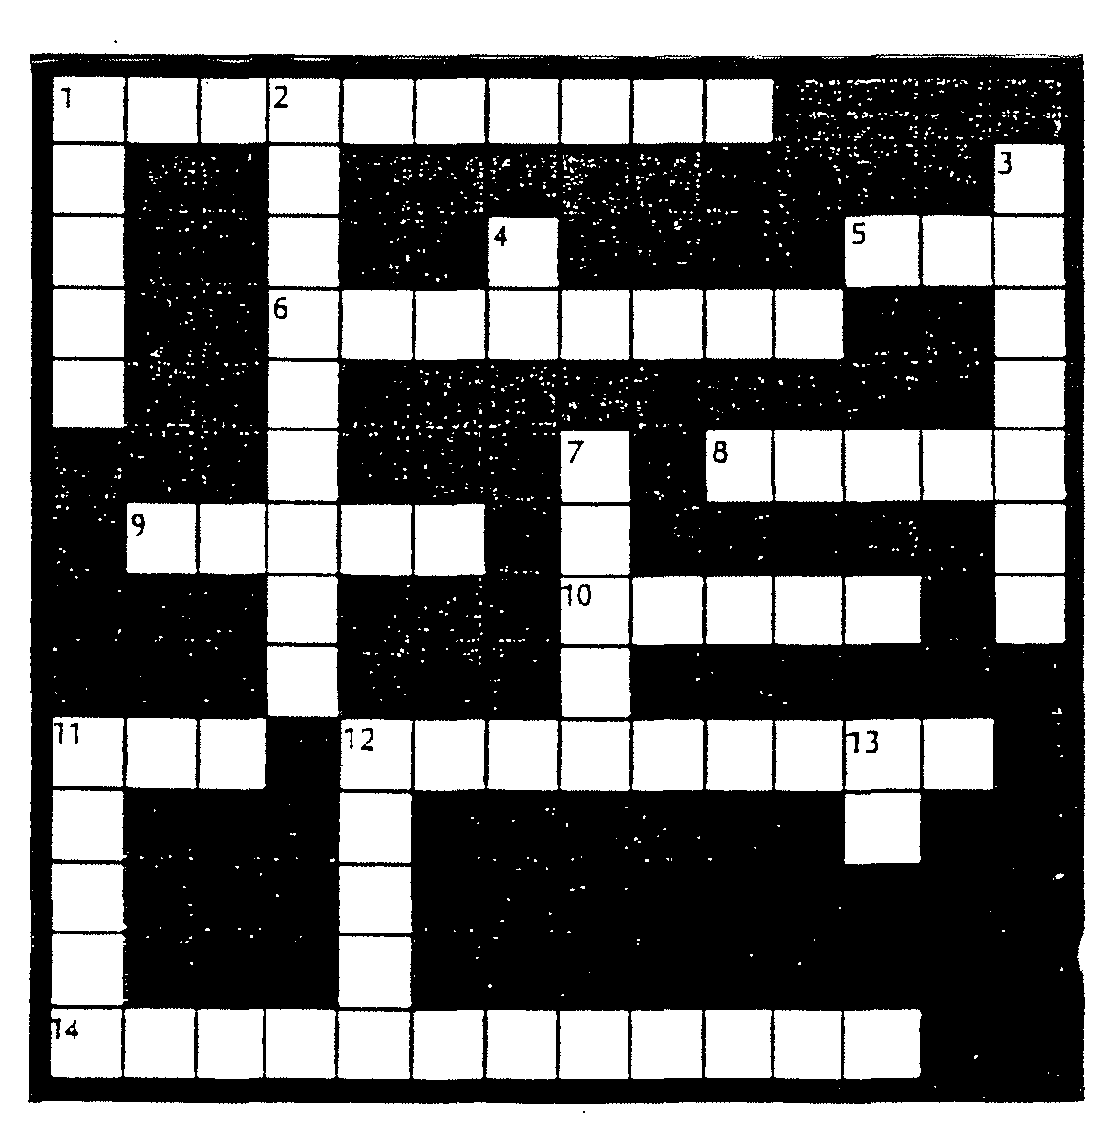

DOWN
1. A drawing using lines and curves (2)
2. Having many forms (6)
3. A ruler: a king (5)
4. A combining form meaning away
7. A combining form meaning water
11. A combining form meaning heat
12. A combining form meaning many
13. A combining form meaning pertaining to (5)

