Lesson 6 Roots Name________________Per________

Part A. Define the Example Words (use a dictionary or Google it) 2018
Term | Definition | Example | Definition of Example
- aero | air | aerobatic
- ethno | race | ethnic
- eu | good | euphoria
- gen | origin ; birth | generation
- homo | same | homogeneous
- hetero | different | heterogeneous
- dox | belief | unorthodox
- para | beside | paralysis
- ortho | correct | orthography
- odont | tooth | periodontal

Part B. Break apart the word to identifying the root definitions (use a dictionary)
Example | Breakdown | Define
- aerometer
- ethnology
- orthographic
- homogenize
- heterography
- homonym
- doxology
- odontology
- homophone
- heteromorphic

Part C. Acrostic Puzzle (use a dictionary, index or Google it – try onelook.com)
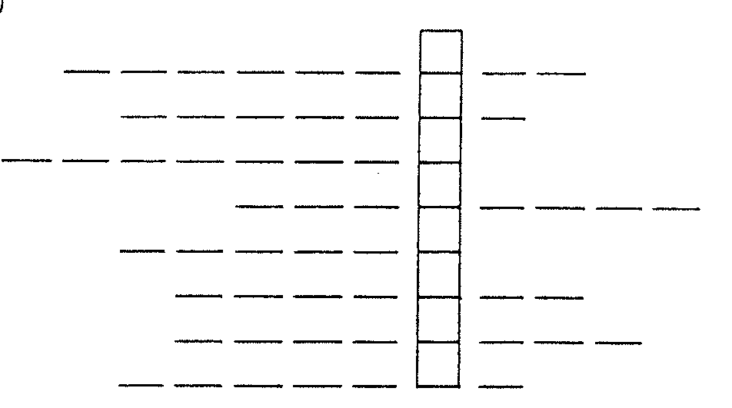
Definition (root word index#)
- Different from the standard belief (56,57)
- A belief opposed to common sense (57,58)
- The correct belief (57,59)
- To praise (30,36,53)
- Performed in the air; aloft (51)
- Good-sounding (53)
- A message delivered by air (2,51)
- A word that sounds the same as another (42,55)
The acrostic word literally means “study of belief”
Part D. Match the example with the definition (use a dictionary or Google it) GRADE __________/12
Term |  | Definition
- _____ | odontograph | - pertaining to aircraft
- _____ | euphemism | - fertilization of a flower by pollen from the same plant
- _____ | aerodrome | - having greater magnetization than a vacuum
- _____ | homogamy | - correction of bones, joints ligaments
- _____ | orthopedics | - a mild expression replacing an offensive one
- _____ | paramagnetic | - a device for correctly positioning gear teeth
- _____ | euthenics | - tooth pain
- _____ | orthopsychiatry | - a small airport
- _____ | homologous | - preventive treatment of the mind
- _____ | odontalgia | - study of ways to better human life
- _____ | homochromatic | - consisting of one color
- _____ | aeronautic | - having the same structure or value

Part E. Find the word to match the definition (use dictionary, index or Google it – try onelook.com)
Definition (root word index#) | Word
- One who corrects teeth (29,59,60)
- Tooth-shaped (19,60)
- A narrative containing moral truth (58)
- An arbitrary constant (7, 58)
- One who performs feats in the air (29, 51)
- To restate in other words (58)
- To originate; procreate (54)
- To make all parts the same (36,54,55)
- Paralysis of the lower half of the body (58)
- Chromosome part determining heredity (54)

Part F. Write 2 sentences. First, use any vocabulary word with a synonym in commas. Second, use a non-restrictive clause to identify your subject.
Word | Sentence
Amoral | There are people who live an amoral, unethical,lifestyle as if laws do not matter.
Astronaut | Neil Armstrong, the first astronaut to walk on the moon, was born in 1930.

