NAME_________________PER_____
Article #1
The Athlete as Agent of Change
By Lonnie Bunch and David Skorton, The Washington Post, adapted by Newsela staff on 10.04.17 Level 1130L 8th grade
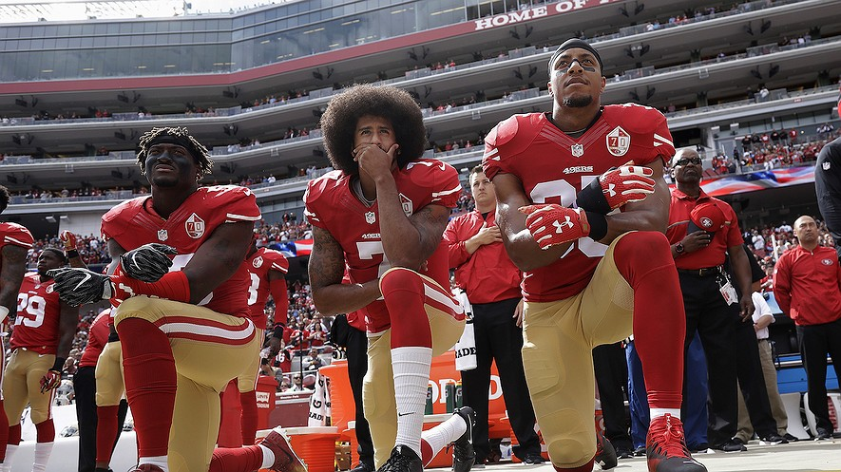
San Francisco 49ers outside linebacker Eli Harold, left, quarterback Colin Kaepernick, center, and safety Eric Reid kneel during the national anthem before an NFL football game against the Dallas Cowboys in Santa Clara, Calif., on Oct. 2, 2016. Photo from AP.

An athlete silently protests during the national anthem. People respond with angry taunts of "traitor," "you're a disgrace" and "leave our country!" Are these angry tweets aimed at National Football League players kneeling during the national anthem? Or heated statements about National Basketball Association players not visiting the White House? No. These insults were thrown at Toni Smith, the then- 21-year-old senior guard on the Manhattanville College women's basketball team, who expressed her opposition to the Iraq War in 2003 by turning her back on the flag.

The history of protest in sports, much like that across society, holds many lessons for us that we can apply to the nation's current anger. Sport has always been a way used to challenge convention. The institution has also been used to prove the worthiness of a marginalized group and prod the nation to live up to its stated ideals.

Athletes Use Platform To Address Injustice
Even before Colin Kaepernick took a knee to highlight police brutality, disagreement had been a part of sports. For decades, athletes have used their fame as a platform to address injustice. Tommie Smith and John Carlos, for instance, raised their fists during 1968 Summer Olympics to protest the unfair treatment of African-Americans. Tennis champion Billie Jean King advocated for Title IX to bring about more gender equality in college athletics. The Phoenix Suns wore Spanish-language versions of their jerseys to protest racial-profiling laws.

If we are to move past reactionary anger, we must acknowledge the fact that the American experience differs among people and groups. Nothing brings that home quite like Jackie Robinson, a hero for breaking the Major League Baseball color barrier. He, too, saw the flag in a different light due to the racism he faced every day. As he wrote in his 1972 autobiography, "I cannot stand and sing the anthem. I cannot salute the flag; I know that I am a black man in a white world."

Robinson and many other athletes have played critical roles in enabling the social change that has created a more inclusive society, often at great risk to their careers. Any suggestion that athletes should "stick to sports" diminishes their courage. The argument also ignores the deeply held tradition of disagreement and debate that makes democratic countries, like the United States, different from dictatorships.

United States Not Living Up To Its Principles
Our nation has always struggled to equally apply the ideals embodied in our Constitution and the Bill of Rights. The United States was founded on the principles of individual liberty, freedom of expression and democracy. Still, people of color, immigrants and women have struggled to receive the full benefits of citizenship. The struggle to perfect our union continues on. Admitting our flaws is not a weakness, nor is it unpatriotic.

As Toni Smith said in a statement following the uproar over her protest, "It is my right as an American to stand for my beliefs the way others have done against me. Being patriotic cannot simply be an empty slogan. Patriotism can be shown in many ways, but those who choose to do so by saluting the flag should recognize that the American flag stands for individuality and freedom."

To many who profoundly love the United States, protest is one of the highest forms of patriotism. The need to "form a more perfect Union" is enshrined in the preamble to the Constitution. The framers knew that the only way to improve our democratic republic is to continuously assess it and work to make it better through principled disagreement and vigorous debate. Such improvement happens regardless of whether the debate comes from the halls of Congress or a football stadium. Increasingly, though, many of us seem to be ignoring the lessons that history has to offer.

Learning From Lessons Of The Past
Museums and other cultural institutions are a potential solution for this. Sport is a powerful way to do so because it resonates with people and passes through the generations. We can display Tommie Smith's warm-up suit and explain why he and Carlos raised their fists at the Olympics. We can also explain the costs they incurred by doing so. Then, generations of people who were not yet born can see both the progress made and the unfinished work ahead of us.

In some ways, sports are conducted on the ultimate level playing field, a fair place where ability outweighs backgrounds, beliefs, race and religion. Athletes have unique insight into working toward a goal and looking past individual glory for the greater good. As such, they have something profound to say about our nation, our freedoms and who we aspire to be. We should listen.
Word Count 779

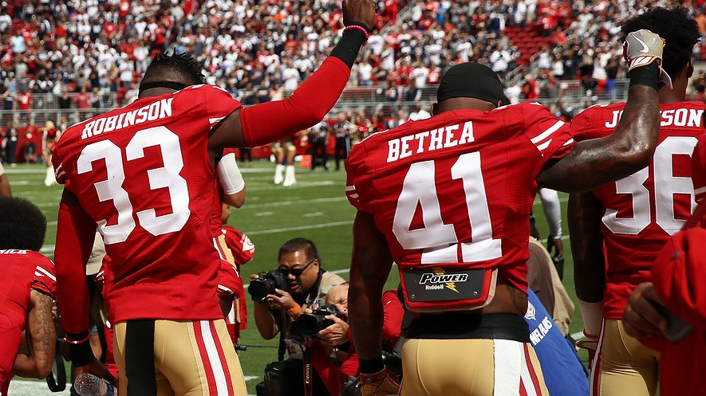
Article #2
PRO/CON:
O'er the Ramparts We Watched as Athletes Were Kneeling

Rashard Robinson (33) and Antoine Bethea (41) of the San Francisco 49ers raise their fists in protest during the national anthem before a football game against the Dallas Cowboys at Levi's Stadium in Santa Clara, California, October 2, 2016. Photo by Ezra Shaw/Getty Images Lexile 1060 7th grade

PRO: Pro players got us talking about an important issue
In August, National Football League (NFL) quarterback Colin Kaepernick began refusing to stand for the national anthem. Many people spoke out against the San Francisco 49ers player for his action. In the midst of a divisive election year, an important discussion about race, class and violence in this country was almost abandoned by the news media.

Then, something surprising happened. Many in the sports world supported Kaepernick and his right to protest. Many did so even as they continued to stand, with their hands over their hearts, for “The Star-Spangled Banner.”

Gregg Popovich coaches the National Basketball Association (NBA)'s San Antonio Spurs. He said he absolutely understands why Kaepernick and other protestors are doing what they're doing. "The important thing that Kaepernick and others have done is to keep it in the conversation," he said. By Tribune Company, adapted by Newsela staff on 10.11.16 Word

Chip Kelly, Kaepernick’s coach, said that his quarterback’s decision was “his right as a citizen.”

Standing On An Athlete's Stage
Kaepernick is not the first famous athlete to take a stand against racial inequality. At a sports awards show in July, basketball players Carmelo Anthony, LeBron James, Dwyane Wade and Chris Paul took the stage together. They urged their fellow athletes to become more socially involved.

Time and again, the sports world’s best athletes have led by example. In 1967, professional boxer Muhammad Ali took a stand against the Vietnam War. In 1968, African American runners Tommie Smith and John Carlos led the black power salutes, a political demonstration at the Summer Olympics in Mexico City, Mexico.

A half-century ago, the St. Louis Cardinals were one of the best teams in baseball, for a number of reasons. Hall of Fame pitcher Bob Gibson once said the Cardinals “were the rainbow coalition of baseball.” Their roster not only included blacks and whites, but Latinos, too.

In 1968, Dr. Martin Luther King Jr. was assassinated. The next morning, Gibson, who is black, got into a heated conversation about racial equality with his catcher, Tim McCarver, who is white. Years later, McCarver wrote, “Bob and I reached a meeting of the minds that morning. That was the kind of talk we often had on the Cardinals.”

We need that kind of direct, honest talk again.

Trouble For Taking A Stand
Of course, many sports stars in the 1960s were punished for taking a public stand. Smith and Carlos were stripped of their Olympic medals. Ali was banished from boxing for years for refusing to fight in the Vietnam War. It took the country years to acknowledge the courage and wisdom in the positions they took.

President Barack Obama recently said that what Smith and Carlos did may have been controversial at the time, but it created opportunity for future generations.

We find ourselves at a similar crossroads today, and a growing number of athletes and coaches realize it. They have dared to hold a mirror up to the rest of us, urging us to do better as a nation. It is our loss if we refuse to listen.

CON: This is No Place to Stage a Protest
Americans of all economic classes and backgrounds have always been able to escape life’s troubles by watching sports. However, San Francisco 49ers quarterback Colin Kaepernick may change that.

He is not the first athlete to mix politics and sports. At the 1968 Summer Olympics in Mexico City, for example, medal-winning runners Tommie Smith and John Carlos were expelled for holding up black-gloved fists during the the national anthem.

Kaepernick is not even the only one to make a political statement at a sporting event this year. In July, Minnesota Lynx players, part of the Women’s National Basketball Association, wore Black Lives Matter T-shirts before a game. Black Lives Matter is an activist-led movement that protests against discriminatory practices toward black people by police and the courts. Four off-duty police officers providing security for the event walked off the job, staging their own protest.

Kaepernick's position is more high-profile, though, and his actions have sparked similar protests everywhere from high schools to professional leagues. While some have voiced their support of Kaepernick, the general public may have a different view. NFL viewership is down this fall, and a recent poll found Kaepernick to be the most disliked NFL player.

What Is Too Far?
In protest movements, it's common for protesters to try push things to the next level. If
athletes can kneel during the national anthem, can they turn their back? Can they stand on
a U.S. flag, or even burn it? At some point, school administrators, coaches, sports leagues,
reporters and fans will have to think about this. They will have to decide when a protest
goes too far.
I do not question someone’s First Amendment right to express their views, but I do
question the venue these athletes have chosen. I also question their target. By protesting
the national anthem, they are protesting America. It is true that America has at times failed to live up to its ideals, but it has also made
progress.
There have been some tragic events lately involving black men and the police. America
did not cause these tragedies, though. They occurred in Charlotte, North Carolina, Tulsa,
Oklahoma, New York City and other places. They are local incidents involving local people.
Some police officers may have failed the African-American community, but most
Americans are outraged when injustices occur. They want those responsible to be held
accountable.

Start A Charity Or Nonprofit
If famous athletes want to make a difference, there are better ways than protesting the national anthem.

Both Kaepernick and the 49ers recently announced they will be donating to charities focusing on racial issues. Shouldn’t that have been their initial response? If some athletes continue to kneel during the national anthem, those of us who still take pride in America should stand a little taller. Playing the national anthem is a time for patriotism, not politics.
Count 1,033

Assignment: Interview 2 adults and 2 teens regarding their thoughts on this issue.
Adult_______________ Adult______________ Teen____________ Teen___________
“The Athlete as Agent of Change” Quiz
1 Which sentence from the article would be MOST important to include in an objective summary of the article?
(A) Sport has always been a way used to challenge convention.
(B) The Phoenix Suns wore Spanish-language versions of their jerseys to protest racial-profiling laws.
(C) Admitting our flaws is not a weakness, nor is it unpatriotic.
(D) Increasingly, though, many of us seem to be ignoring the lessons that history has to offer.
2 The CENTRAL idea of the article is developed by ____
(A) highlighting the success athletes have had with their protests.
(B) detailing the pros and cons of protest in athletic competitions.
(C) outlining the history of inequality in the United States.
(D) providing examples of times when athletes stood up for freedoms.
3 Read the section "United States Not Living Up To Its Principles."
Which of the following sentences from the section BEST explains HOW the United States has declined to guarantee the rights outlined in the Constitution and the Bill of Rights?
(A) Our nation has always struggled to equally apply the ideals embodied in our
Constitution and the Bill of Rights.
(B) The United States was founded on the principles of individual liberty, freedom
of expression and democracy.
(C) Still, people of color, immigrants and women have struggled to receive the full
benefits of citizenship.
(D) The need to "form a more perfect Union" is enshrined in the preamble to the
Constitution.

4 According to the article, athletes deserve a platform to be heard because they have a strong understanding of teamwork and vision.
Which selection from the article BEST supports the idea outlined above?
(A) The institution has also been used to prove the worthiness of a marginalized group and prod the nation to live up to its stated ideals.
(B) Such improvement happens regardless of whether the debate comes from the halls of Congress or a football stadium.
(C) In some ways, sports are conducted on the ultimate level playing field, a fair place where ability outweighs backgrounds, beliefs, race and religion.
(D) As such, they have something profound to say about our nation, our freedoms and who we aspire to be.

“Pro/Con Anthem Protest” Quiz
Quiz
1 Which section of the article highlights the idea that it is important to discuss proper ways for
athletes to make a political statement?
(A) "Standing On An Athlete's Stage"
(B) "Trouble For Taking A Stand"
(C) "What Is Too Far?"
(D) "Start A Charity Or Nonprofit"
2 Which excerpt from the section “Standing On An Athlete's Stage” BEST explains why the PRO author cited the St. Louis Cardinals as a good example?
(A) They urged their fellow athletes to become more socially involved.
(B) Hall of Fame pitcher Bob Gibson once said the Cardinals “were the rainbow
coalition of baseball.” Their roster not only included blacks and whites, but
Latinos, too.
(C) The next morning, Gibson, who is black, got into a heated conversation
about racial equality with his catcher, Tim McCarver, who is white.
(D) Years later, McCarver wrote, “Bob and I reached a meeting of the minds that
morning. That was the kind of talk we often had on the Cardinals.”
3 How does the viewpoint of the PRO author compare with the viewpoint of the CON author?
(A) Both agree that Kaepernick's protest creates an opportunity for future
generations.
(B) Both support professional athletes’ opposition to racial inequality.
(C) Both agree that professional athletes should donate to charities that focus on
racial issues.
(D) Both support Kaepernick’s protest of the national anthem.

4 In which of the following sentences does the CON author acknowledge two different points of view?
(A) Kaepernick's position is more high-profile, though, and his actions have
sparked similar protests everywhere from high schools to professional
leagues.
(B) It is true that America has at times failed to live up to its ideals, but it has
also made progress.
(C) If famous athletes want to make a difference, there are better ways than
protesting the national anthem.
(D) If some athletes continue to kneel during the national anthem, those of us
who still take pride in America should stand a little taller.

Write an Persuasive Essay Introduction

Write 4 sentences in this order:

- Hook - An interesting fact, quote or shocking statements. No questions.
- Background 1 - Some say . . . because . . . (tell us about one side - no bias)
- Background 2 - Others say . . . since . . . (tell us about the other side - no bias)
- Thesis / Claim (state an opinion, BUT no “I think”, “In my opinion”, nor “I believe”)

Steps to write a digital intro:
- Zocchi.weebly.com
- Select Jupiter ELA Grades
- Click My Files
- Click Upload New
- Click New Juno Doc

Use this checklist to ensure an A on this assignment!

  - Type title in small window at the top
  - Type header (student #, Ms. Zocchi, Per, Day-Month-Year)
  - Create a title that is NOT the topic nor the assignment
  - Type 4 sentences
    - Avoid writing questions
    - Avoid using first person pronouns (I, me, my)
    - Avoid taking sides in the middle of the intro
- Click Turn in
Click - Assignment “Persuasive Intro Protests”
Tip: You have not “turned in” your work unless in “My Files” it is listed as “turned in”. Do NOT confuse this with your Simple Sentence assignment.

If you cannot figure out Juno Docs nor Jupiter, either type it in an email to me or hand write it.

