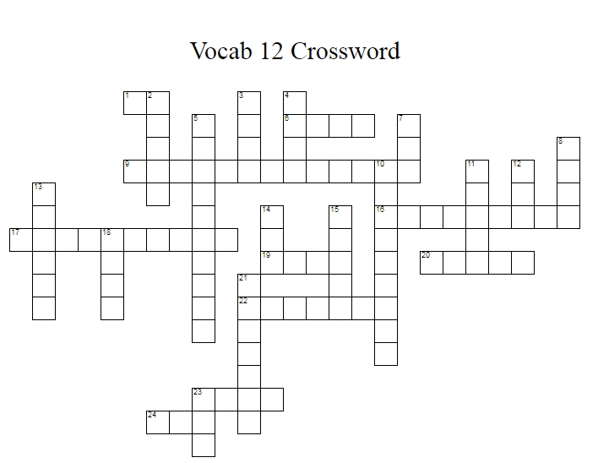

ACROSS
1 The root word for away
6 The root word for name
9 Not able to be delivered (11)
16 A second-year student (113)
17 Not having the correct belief
(57 &59 & 117)
19 The root word for knowledge of
20 The root word for measure
22 The root word for feeling
23 The root word for ten
24 The root word for three

DOWN
2 The root word for race
3 The root word for halt
4 The root word for cut
5 A device for regulating temperature
(1 & 116)
7 The root word for to make
8 The root word for model
10 A device which measures percolation of
water through soil (7, 120)
11 The root word for tooth
12 The root word for life
13 The root word for bird
14 The root word for angle
15 The root word for carving
18 The root word for print
21 The root word for treatment
23 The root word for across

