Lesson 2 Roots Name________________Per________
Part A. Define the Example Words (use a dictionary or Google it)
Term/Definition | Example | Definition of Example
11 baro / weight | barometer
12 centi / hundred | century
13 milli / thousand | millimeter
14 peri / around | periscope
15 tele / far | telescope
16 scope / see | microscope
17 micro / small | microfilm
18 cardio / heart | cardiology
19 oid / form; shape | asteroid
20 ultra / beyond | ultramodern

Part B. Practice breaking apart the examples and identifying the root definitions
(use a dictionary or Google it)
Example | Breakdown | Define
telescopic | Far/see/pertaining to | Pertaining to optical lens to see far away
cardiography
milligram
micromillimeter
telemetric
telegraphic
baroscope
ultramicroscopic
microscopic
ultramicrometer

Part C. Match the example with the definition (use a dictionary or Google it) GRADE __________/12
 | - isobar | - A device to see radar waves
 | - centuplicate | - A 100th anniversary
 | - perigee | - A device to see into the ear
 | - radarscope | - The study of small living things
 | - gyroscope | - A measurement of atmospheric
 | - centennial | - Speaking around the point
 | - micron | - A line of equal atmospheric pressure
 | - peristaltic | - 1000th of a millimeter
 | - otoscope | - Motion of the intestines
 | - millibar | - When the moon is nearest the
 | - periphrasis | - A wheel spinning on an axis
 | - microbiology | - TO make one hundred copies

Part D. Find the word to match the definition (use dictionary, index or Google it – try onelook.com)
Definition (root word index#) | Word
- A device for seeing broadcasts from afar (15)
- A film used to record data in a small space (17)
- The record produced by a cardiograph (2,18)
- Invisible light beyond the violet spectrum (20)
- The science of the heart (18)
- Smaller than what is visible to the eye (9,16,17)
- The measurement around on object (7,14)
- A device to measure small distances (7,17)
- A device to measure atmospheric weight (7,11)
- Literally, a bug with 100 feet (12)

Part E. Acrostic Puzzle (use a dictionary, index or Google it – try onelook.com)
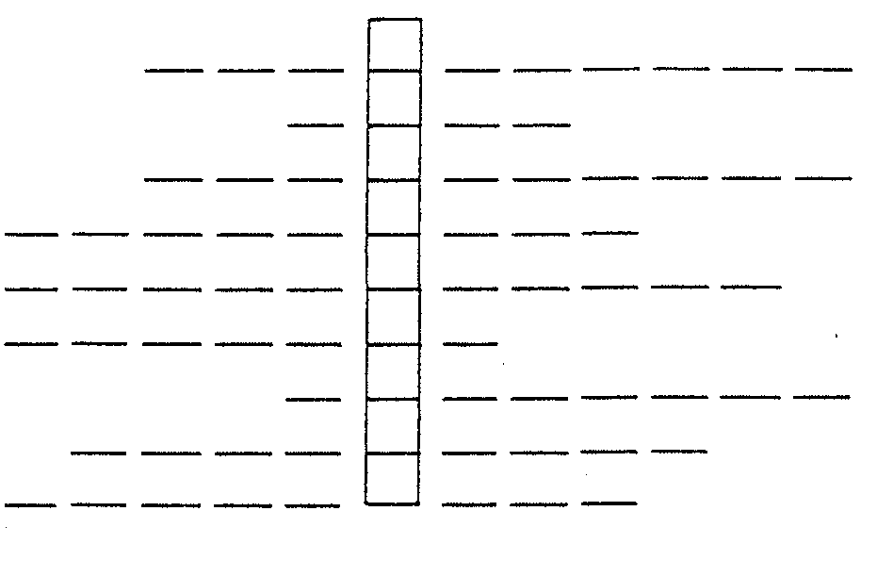

Definition (root word index#)
- 100th of a meter (7.12)
- 100th of a dollar (12)
- A thousand years (13)
- The measurement of the distance of objects (7,15)
- Small V-shaped groove used on records (17)
- A hundred years (12)
- A male voice between base and tenor (11)
- A device for speaking over long distances (15)
- A camera lens that enlarges distant images (15)

The acrostic word literally means written far

