Lesson 3 Roots Name________________Per________
Part A. Define the Example Words (use a dictionary or Google it)
Term/Definition | Example | Definition of Example
21 mega / large | megacephalic
22 sphere / circle | spheroid
23 litho /stone | megalith
24 chrom / color | chromatic
25 dia / between; across | diameter
26 batho / depth | bathysphere
27 bio / life | biology
28 geo / earth | geometrician
29 ist / one who | geologist
30 logy / study of | geology

Part B. Break down the examples and identifying the root definitions (Google or dictionary)
Example | Breakdown | Define
- biologist
- lithoid
- batholith
- geometric
- microbiologist
- bathyscope
- lithogenic
- geographic
- monochromatic
- biometric

Part C. Acrostic Puzzle (use a dictionary, index or Google it – try onelook.com)
Definition (root word index#) | 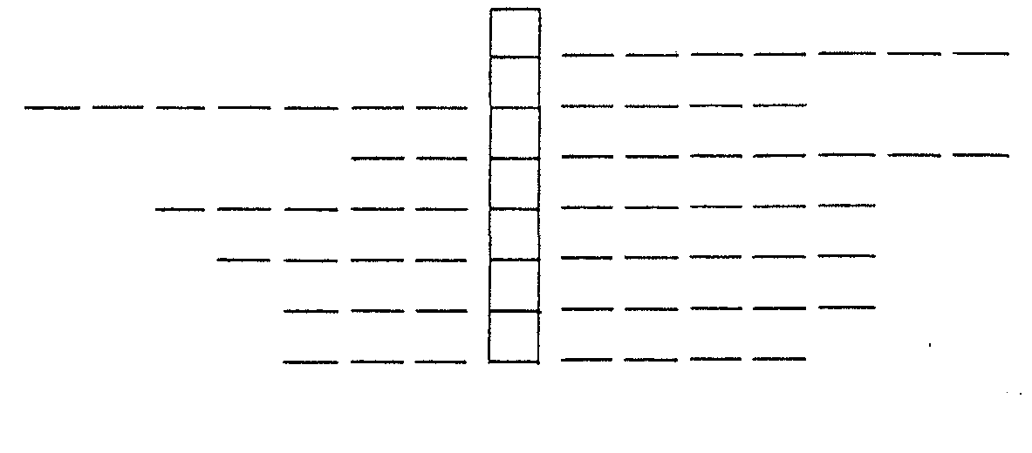
- A conversation between two or more people (25,30)
- The chemistry of living organisms (27)
- The study of handwriting (2.30)
- Art of printing from stone carvings (2,23)
- Pertaining to ones life history (2.9.27)
- A device to magnify sound (21)
- Mathematics of earth sciences (7,28)
The acrostic word literally means written across

Part D. Match the example with the definition (use a dictionary or Google it) GRADE __________/12
Term |  | Definition
_____ | pathology | - The solid part of the earth
_____ | lithophyte | - Removing living issue for diagnosis
_____ | spherometer | - Abnormally large heart
_____ | lithosphere | - A human culture which used stone tools
_____ | megaton | - The study of the nature of disease
_____ | geode | - A hollow stone containing crystals
_____ | biopsy | - A very large city
_____ | physiology | - Measures curvature of surfaces
_____ | megalocardia | - Study of the functioning of living organisms
_____ | stratosphere | - A plant that grows on rocks
_____ | megalopolis | - Upper part of the atmosphere
_____ | Neolithic | - A million tons

Part E. Find the word to match the definition (use dictionary, index or Google it – try onelook.com)
Definition (root word index#) | Word
- Identifying a disease from its symptoms (25)
- A device which measures depths in water (7,26)
- Centered around the earth (9,28)
- A history of a person’s life (2,27)
- The shape of the earth: a spheroid (19,28)
- To print from designs carved on stone (2,23)
- One who treats heart disease (18,29,30).
- From one corner of a rectangle to another (25)
- One who studies handwriting (2,29,30)
- Circular-shaped; globular (9.22)

Part F. (20 points)- Write a compound subject sentence with a vocab word.
Vocab Word | subjects | complete sentence
telescope | Mary and Joe | Mary and Joe used a telescope to see the moon.

