Student_______________________ Per_____

Root Vocab 5 Crossword

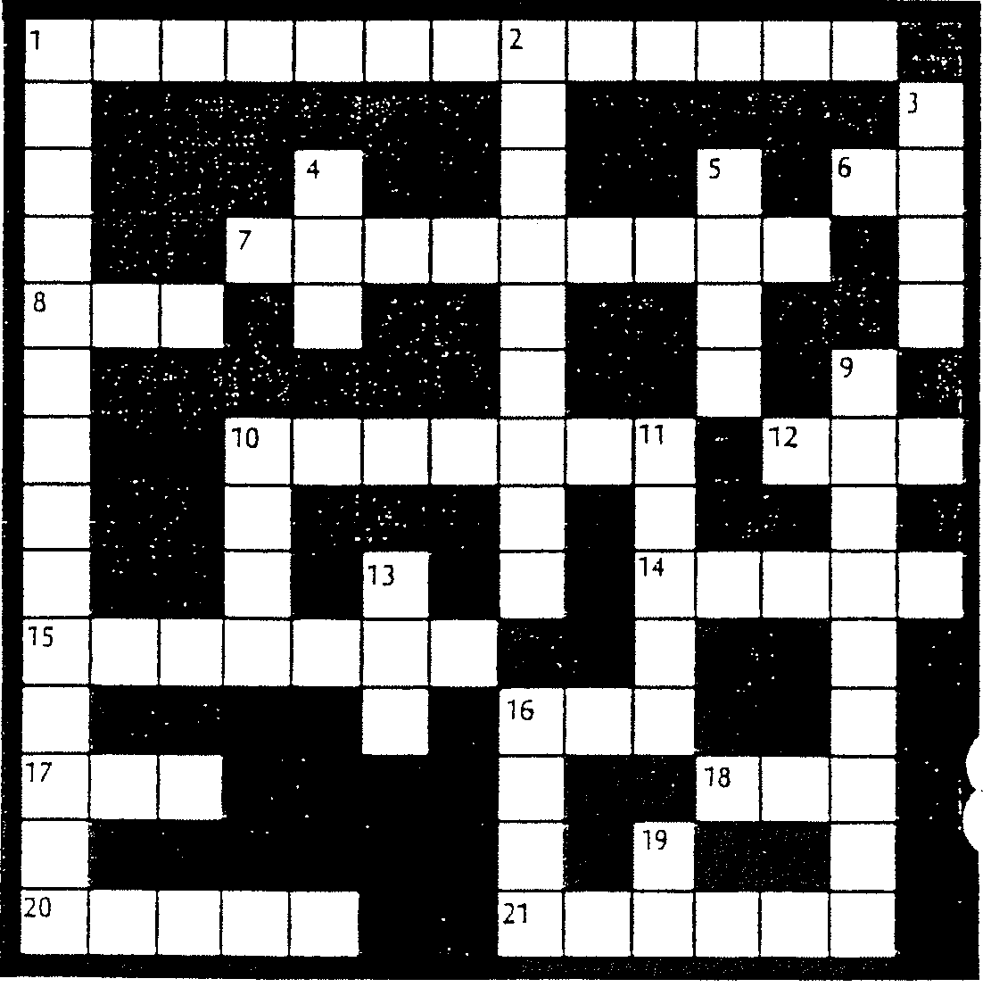

ACROSS
1 A false science (43)
6 A combining form meaning away
7 Measuring objects at a distance (15,47)
8 A combining form meaning form
10 The act of baptizing (49)
12 A combining form meaning place
14 A combining form meaning color
15 A word with the opposite meaning (37, 42)
16 A combining form meaning life
17 A combining form meaning to make
18 A combining form meaning between
20 A combining form meaning written
21 A combining form meaning bird

DOWN
1 An engraving by photography (41)
2 A social system in which goods are owned communally (49)
3 A combining form meaning around
4 A combining form meaning earth
5 A combining form meaning written
9 Literally "wholly written" (2, 48)
10 A combining form meaning weight
11 A combining form meaning small
13 A combining form meaning same
16 A combining form meaning weight
19 A combining form meaning not

