Student_____________________________Per__________
Vocab 2 Crossword

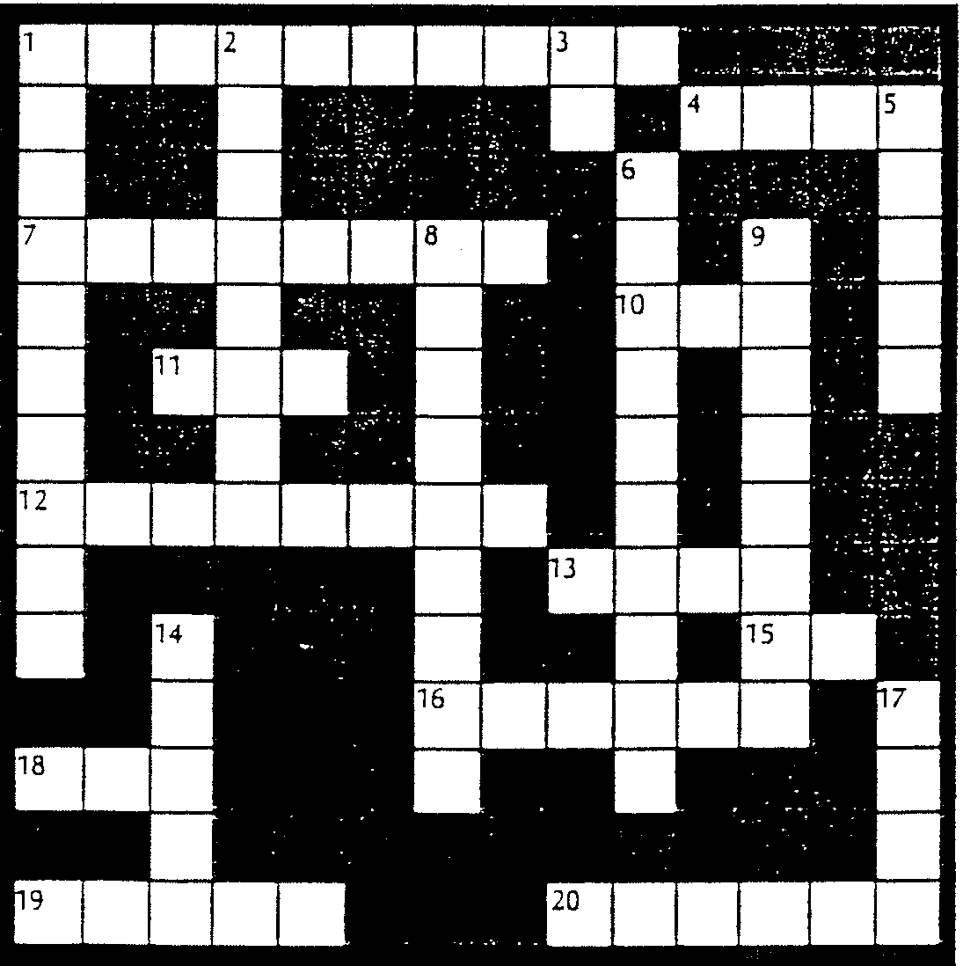

ACROSS
1. A thermometer divided into 100 degrees (12)
4. A combining form meaning written
7. A kind of teletypewriter (15)
10. A combining form meaning place
11. A combining form meaning shape
12. A broadcast using television (15)
13. A combining form meaning one
15. A combining form meaning pertaining to
16. A portion of time (14)
18. A combining form meaning before
19. A combining form meaning heat
20. A combining form meaning heart

DOWN

1. 100th of a liter (12)
2. To transmit by television (15)
3. A combining form meaning away
5. A combining form meaning many
6. Supersonic (9,20)
8. A device used to see around (14,16)
9. Shaped like a sphere (19)
14. A combining form meaning see
17. A combining form meaning weight

