Lesson 5 Roots Name________________Per________

Part A. Define the Example Words (use a dictionary or Google it)
Term | Definition | Example | Definition of Example
- photo | light | photoelectric
- onym | name | acronym
- pseudo | false | pseudopod
- morph | form | amorphous
- proto | first | protocol
- type | print/ model | prototype
- metry | measurement | optometry
- holo | whole | holomorphic
- ism | act; state of | terrorism
- meta | between ; beyond | metamorphic

Part B. Break apart the word to identifying the root definitions (use a dictionary)
Example | Breakdown | Define
- photolithography
- pseudonym
- toponomy
- anthropomorphic
- telephotography
- protomorphic
- holography
- hydrometry
- photobiotic
- photographic

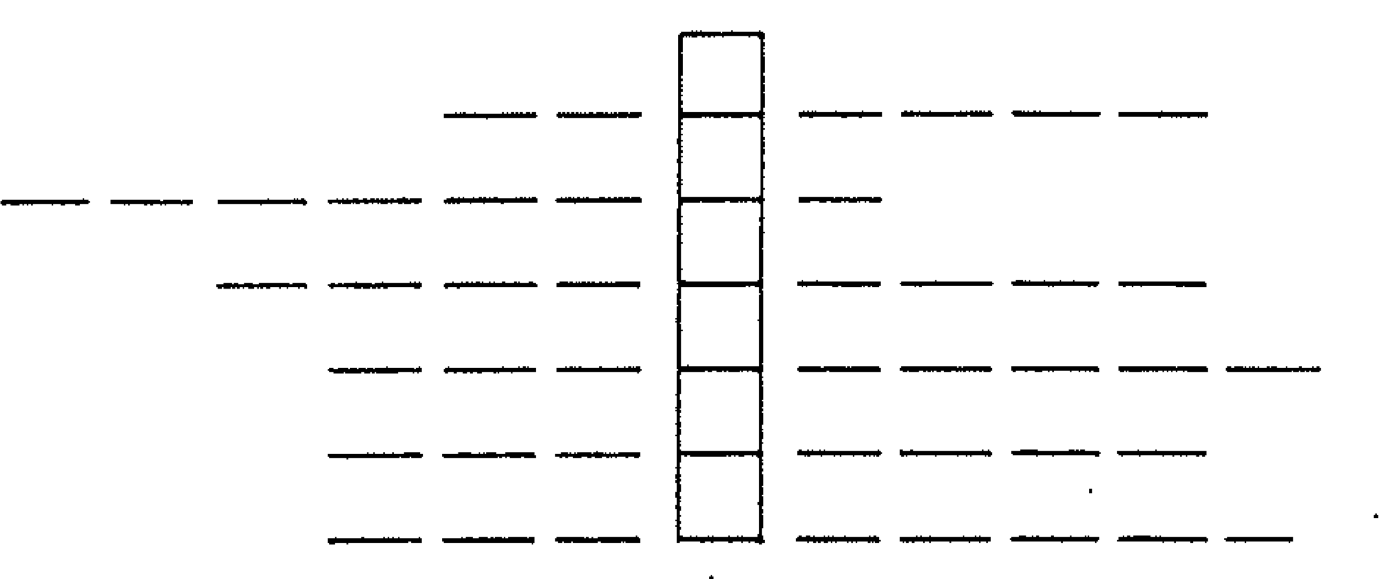
Part C. Acrostic Puzzle (use a dictionary, index or Google it – try onelook.com)
Definition (root word index#)
- conforming to a type (46)
- The math dealing with space and figures(28,47)
- A photographic printing plate (41,46)
- A cell which reacts to light (41)
- One and only representative of a group(5, 46)
- Act of producing a hypnotic state (49)
The acrostic word literally means “the first”
Part D. Match the example with the definition (use a dictionary or Google it) GRADE __________/12
Term |  | Definition
- _____ | Suitable for being photographed | - protolithic
- _____ | Undergoing a total cleavage | - pseudocarp
- _____ | All animals except protozoans | - photogenic
- _____ | The formative material of animal embryos | - pseudomorphic
- _____ | Literally a “false fruit” | - anonymous
- _____ | Animals whose body consists of one cell | - protoplasm
- _____ | Process of plant growth when exposed to light | - holoblastic
- _____ | Wholly consumed by fire | - trigonometry
- _____ | Math dealing with triangles | - photosynthesis
- _____ | Pertaining to the earliest stone age | - metazoan
- _____ | Having an irregular or deceptive form | - protozoan
- _____ | Unknown name | - holocaust

Part E. Find the word to match the definition (use dictionary, index or Google it – try onelook.com)
Definition (root word index#) | Word
- A false form (43,44)
- The same name; similar name (31,42)
- The study of forms and structures of animals (30,44)
- A lens which enlarges distant objects (15,41)
- An instrument for measuring light (7.41)
- A machine which sets type (46)
- State of being alcoholic (49)
- A picture taken by a camera (2,41)
- Dealing with things beyond the physical (50)
- A machine for writing type (46)

Part D. Write two sentences using any vocabulary word from Lesson 5. You must use a synonym, or defining phrase, in commas.

Word | Sentence
Amoral | There are people who live an amoral, or unethical, lifestyle as if laws do not matter.

